**“Detailed Proposal**

**Of**

**Lead Management Platform**

**V1.2”**

**Contents**

1. Executive Summary 3

2. Few Advantages of using WebMobril 3

3. Project Overview 3

4. Deliverable Components 4

5. User flow diagram 5

6. Project Estimation 6

7. Technologies 6

8. Commercials and Payment terms: 6

9. Features and Scope of Work 7

10. Administrative Panel 8

11. Highlights 9

12. Requirements from Client 9

13. Project Management 10

14. Proposed Team of Project 11

15. Work Model 11

16. Project Methodology & Timelines 11

17. Process Flow Diagram 12

18. Terms and Conditions 12

# Executive Summary

WebMobril is an ISO 27001 certified company headquartered at Noida with Development centres across India in Bangalore, Chandigarh, and Indore with a team of 400+ in-house professionals. We are a leading Mobile app development, Cyber Security Services, Website Development and Digital Marketing service provider company.

# Few Advantages of using WebMobril

* Quick Response Time
* Specialized team - Certified Professionals
* Proven Track Record
* Verifiable References
* SLA Based agreements
* Specialized and focused service area
* Agile Methodology
* ISO Based Processes

# Project Overview

The proposed project comprises the design and development of the Lead Management Platform, below are the overall summary and the crux of the project.

* **Business Need**

To have a platform where Employees can check the duplicate leads and manage their calls, leads, RFP requests, and DSR data on the platform.

* **How the solution will help to achieve the need.**

As a solution, we are providing a website that will fulfill the need of Employees where they can log in and efficiently handle their calls, leads, RFP requests, and DSR (Daily Status Report). Additionally, they can conveniently access and verify the duplicate lead data on the website.

**Stakeholders involved in the Website**

|  |  |
| --- | --- |
| **ACTOR** | **What he can do on the Website Created** |
| Admin | * Admin will be able to manage Cluster head, view Manager and BD data, and also manage the content of the website. |
| End-User  (BD) | * BD will be able to log in and check the duplicate leads and manage their calls, leads, RFP, and DSR data on the platform. |
| End-User  (Manager or TL) | * TL will be able to login and check the duplicate leads and manage the BD and their calls, leads, RFP, and DSR data on the platform |
| End-User  (Cluster or Branch Head) | * Cluster head will be able to login and manage the TL on the platform |

**Project Scope and Deliverable Components**

This project scope comprises the design of the following components to deliver:

* **Design & Development of Lead Management Platform**
* **Development of Backend, Admin Panel & API Integration**

# Deliverable Components

These are the deliverables component that will be delivered post completion of the different phases in the project.

|  |
| --- |
| **Deliverables Components** |
| **Business Analyst:** Proposal, UFD, Wireframes, WBS & FSD Document |
| **Project Management:** Gantt Chart, Delivery Plan, Sprint Plan |
| **Design Team:** Figma Design Link/ Web design link |
| **Development End:** Architecture Diagram, API Documentation |
| **QA Team:** Test Cases and Test Results |
| IP & Source Code Delivery |

# User flow diagram (BD)

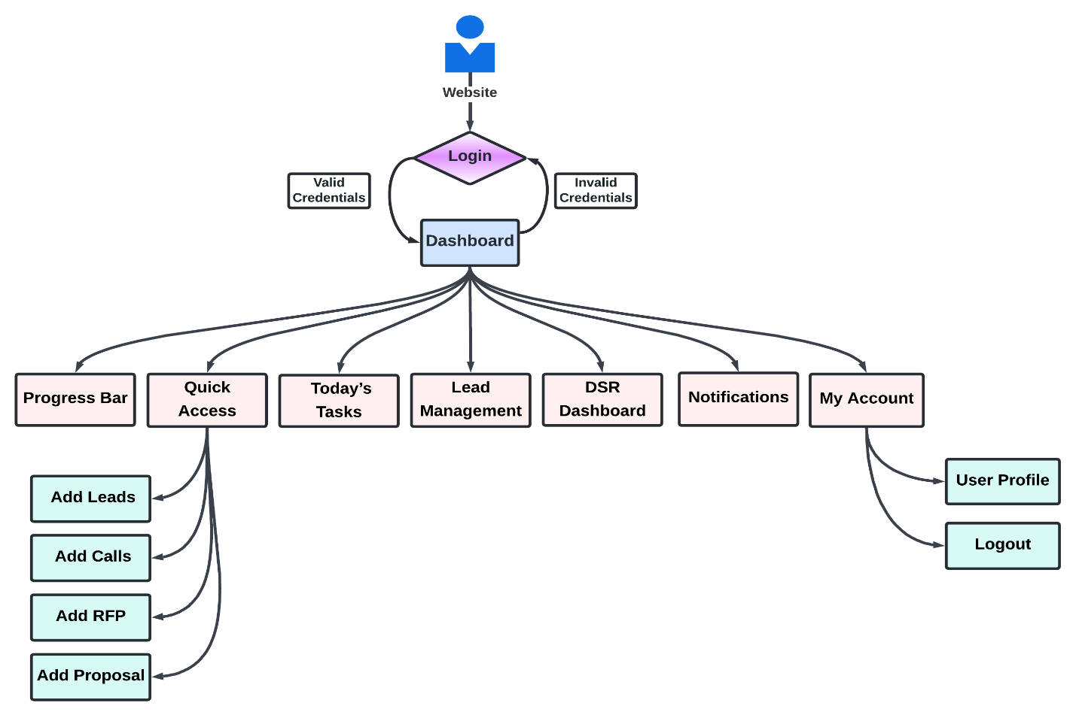

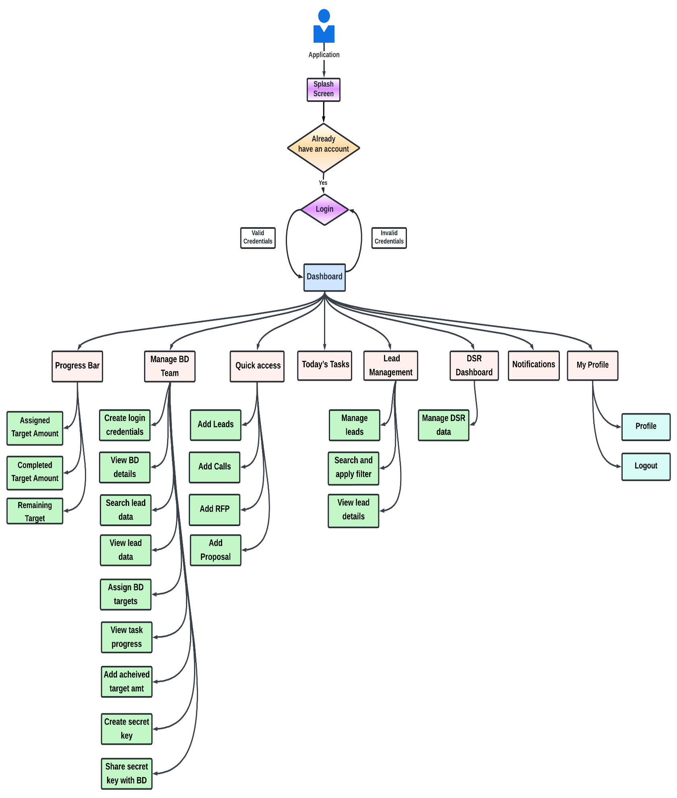**User flow diagram (TL)**

**User flow diagram (Cluster Head)**

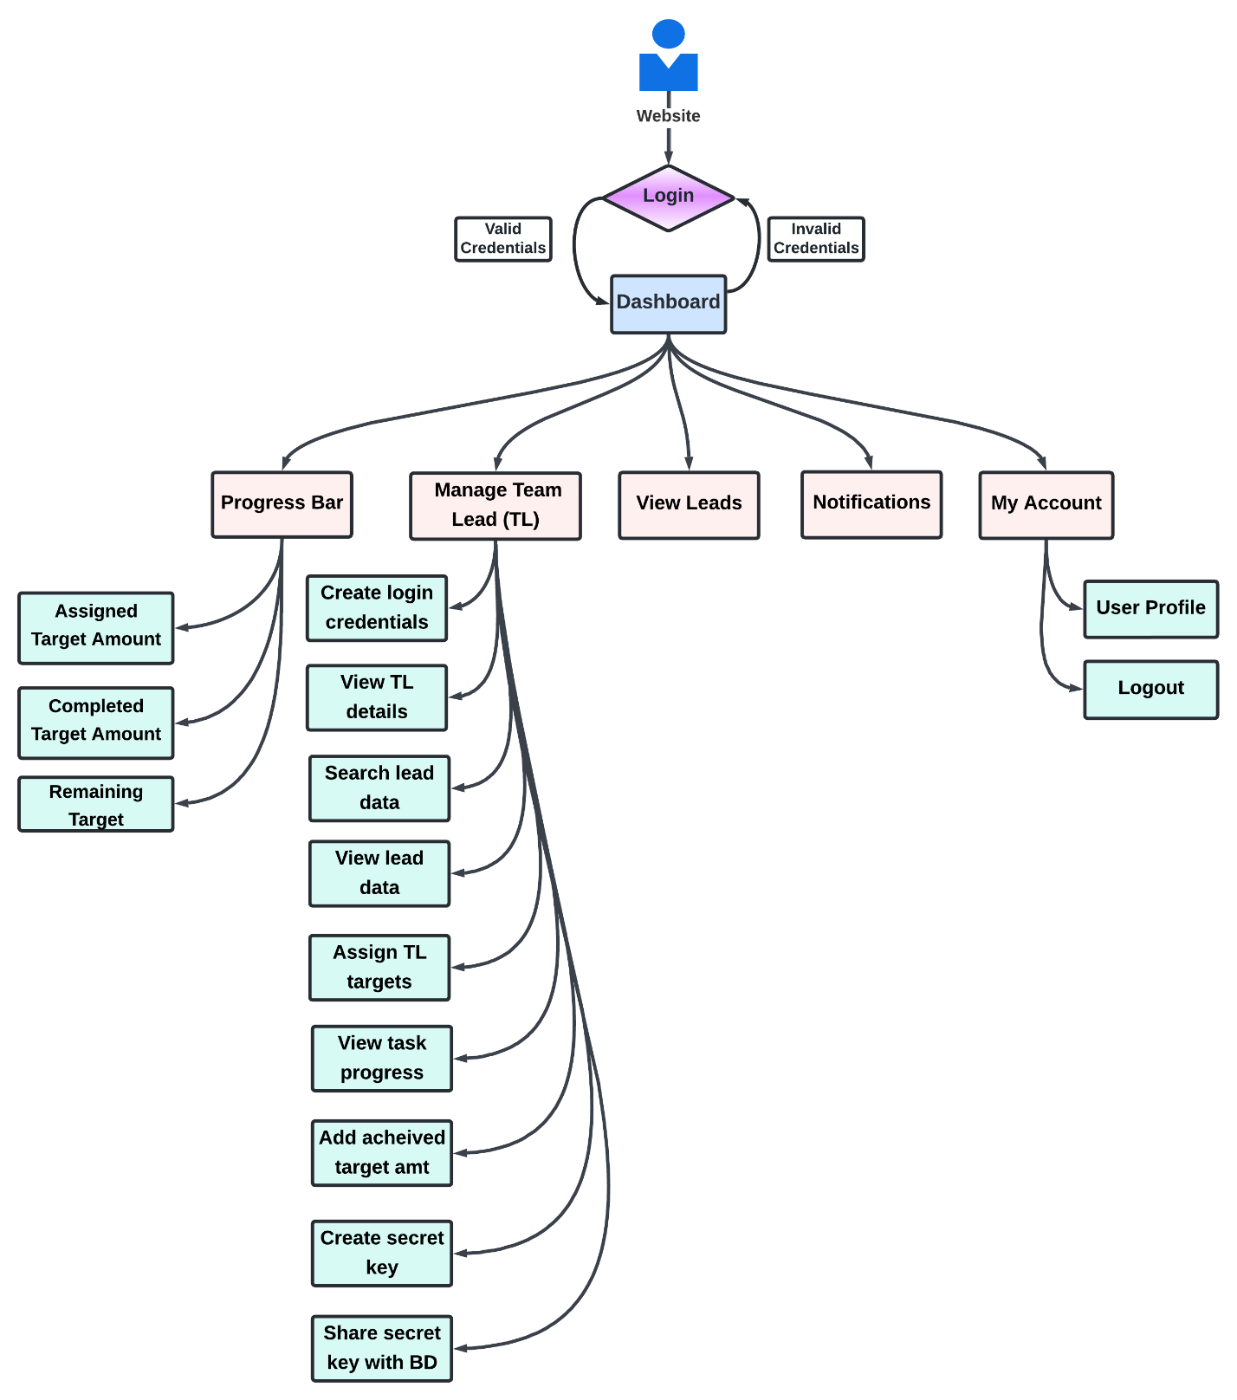

# Project Estimation

**Proposed quote is USD 0000 and total efforts estimate would be 5 months. On your approval and confirmation, we will be working on project delivery schedule on the basis of our resources allocation plan.**

**\*\* 4.5% of PayPal fee will applicable in case of payment via PayPal.**

**\*\* No Additional payment processing fee will be applicable if payment is processed through Bank Transfer**

** The cost is estimated on the basis of high level requirements however there may be a variation of + - 10% based on the final requirements freeze.

This quote is valid for 2 weeks from the proposal date.

# Technologies

|  |  |  |
| --- | --- | --- |
| **Development Phases** | | **Tools & Technology** |
| Requirement Analysis, Proposal Drafting, SRS writing and Wire framing | | * MS Office Word 2016 * MS Office Visio 2016 * MS Office Power Point 2016 * Axure |
| Website Development | Website Design | * React js |
| Backend Development | | * Node js |
| Database | | * MySQL/Mongo DB |
| Quality Assurance & Testing | | * Test Cases & Plans – MS Office Word 2016 * Testing – Manual |

# Modules Distributions:

|  |  |  |
| --- | --- | --- |
| **Sl. No.** | **Modules** | **Duration** |
| 1 | Users Login Module | 1 month |
| 2 | BD Flow Module | 1 month |
| 3 | Team-lead (Manager) Module | 1 month |
| 4 | Cluster head (branch head) Module | 1 month |
| 5 | Admins and Reports Management Module & Email management Module | 1 month |
|  | **Total Duration** | **5 Month** |

# Features and Scope of Work

* + - * **Web-Based Flow for Employees**
* **Login**
  + Employees will be able to login on the platform using the below credentials.
  + **User ID**
  + **Password**

**Note- Login credentials would be provided by the admin to the Employees.**

**Note- After entering the login credentials, users need to enter the secret key to reach the dashboard, Users will get 3 attempts to enter the correct key.**

* **Dashboard**
  + Employees will be able to view the below tabs on the home page.
  + **Progress Bar**
  + **Quick Access**
  + **Today’s Tasks**
  + **Lead Management**
  + **DSR Dashboard**
  + **Notifications**
  + **My Profile**
* **Progress Bar**
  + Employees will be able to view the progress bar with the below details and also view the percentage and color in the details.
  + **Assigned Target Amount**
  + **Completed Target Amount**
  + **Remaining Target**
* **Quick Access**
  + Employees will be able to view the below buttons he Quick Access.
  + **Add Leads**
  + **Add Calls**
  + **Add RFP**
  + **Add Proposal**
* **Add Lead** 
  + Employees will be able to add lead data by adding the below details.
  + **Select Client’s Requirement type (App/Web/Game/Digital Marketing/Blockchain/Cyber Security)**
  + **Lead Type (Email/LinkedIn/Upwork)**
  + **Lead Source (External/Internal/Self)**
  + If Employees will select Email or LinkedIn, Employees need to enter the below details.
  + **Enter Client Name**
  + **Add Note (Select Predefined Tags)**
  + **Enter the Client’s Country**
  + **Enter the Client’s Contact Number**
  + **Enter the Client’s Whatsapp Number**
  + **Enter the Client Email Id**
  + **Enter the Client's LinkedIn URL (Mandatory if lead type is LinkedIn)**
  + If Employees will select the Upwork, Employees need to enter the below details.
  + **Upwork Job URL**
  + **Bid URL**
  + **Proposal Amount**
  + **Client’s Budget**
  + **Add Note (Select Predefined Tags)**
  + After filling in all the above details, Employees will view the following message (Lead Data Updated) if lead data is not duplicated.

**Note- If the lead data is already updated then the following message (The X employee handling this lead, Source Type, and Lead Assigned date) will be displayed.**

* **Add Calls**
  + For adding the calls, they will have to select the lead or enter the Lead ID.
  + **Lead Type ((Email, Upwork or LinkedIn))**
  + **Select Meeting Date and Time**
  + **View Client’s Requirement (Edit)**
  + **Select the Type of Call (Initial, 2nd call, 3rd call, 4th call, 5th call, 6th call, Proposal Walkthrough, features list discussion, After Proposal, Final Discussion, Further Discussion, Kick Off Meeting or On-Board Discussion )**
  + **Select Mode of Call (Zoom/Skype/Google Meet/Teams/Viber/Whatsapp)**
  + **Comments (If Yes)**
* **Add RFP** 
  + Employees will be able to Add RFP by adding the below details.
  + **Select Lead or Enter Lead ID**
  + **Enter MOM (Minutes of Meeting)**
  + **Add Attachments**
  + After adding all the above details, Employees will be able to submit the request for RFP.
* **Add Proposal**
  + Employees will be able to add RFP on the platform.
  + When the employees will adding the RFP, they will have to select or add the below.
  + **Select lead or Enter Lead ID**
  + **Add Proposal**
  + **Add Attachments (Proposal/WBS/Wireframes)**
  + **Select Pending**

**Note- If employees will select the Add Proposal, employees need to add the attachments mandatory on the platform.**

* **Today’s Tasks**
  + Employees will be able to view the below details in this tab.
  + **Today’s Task (Pending or Completed)**
  1. **Number of Follow Up**
  2. **Number of Request RFP**
  3. **Scheduled Calls**
  + Employees will be able to view last week’s tasks details on the platform.
* **Leads Management**
  + Employees will be able to manage leads on the platform.
  + Employees will be able to search leads by name and view the details.
  + Employees will also apply the filter (Date/Time/Lead Type/Calls/Follow-up) and view all the details.
  + Employees will be able to view the below details of the leads on the platform.
  + **Number of Leads Added**
  + **Lead Source (External/Internal/Self)**
  + **Lead Type (Email/LinkedIn/Upwork)**
  + **Client Name**
  + **Client's Email Address**
  + **Client's Country**
  + **Client's Skype ID**
  + **Client's Contact Number**
  + **Client’s Whatsapp Number**
  + **Client's LinkedIn URL (If lead source is LinkedIn)**
  + **Upwork Job URL (If lead source is Upwork)**
  + **Client's Requirement**
  + **Current Lead Status (Meeting done/ Response - (whatever response got from the client)/ Not a lead – Lead Returned/fake lead/ No requirements – Not Interested/Budget issue/ No response after intro mail/**
  + **Follow up Status (1 to 8th)**
  + **View Remarks**
  + **Call Status (Meeting Done/ Rescheduled/Client did not joined)**
  + **View RFP Status (View Attachments)**
* **DSR Dashboard (Daily Status Report)**
  + Employees will be able to manage and view their DSR with the below details.
  + **Number of Leads Assigned (Today)**
  + **Number of Positive Responses**
  + **Number of Negative Responses**
  + **Number of Follow-ups**
  + **Number of LinkedIn Messages**
  + **LinkedIn Response**
  + **Number of Bids (Upwork)**
  + **Upwork Response**
  + **Number of Calls Scheduled with status (Successful or Unsuccessful)**
  + **Number of Proposal Submitted/ Estimation Submitted/ Understanding and Queries Submitted/ Response Shared/ Features List Shared to the Clients**

**Note- Employees will be able to edit their DSR data before 12 am after that DSR will be automatically sent to the Management.**

* **Notifications**
* Users will receive the notifications on the platform.
* **My Profile**
* **Profile: -** Employees will be able to view their profile details: - Name, Email address, Employees ID, Branch and Phone Number.
* **Logout: -** Employees will be able to logout from the platform.

**Note- Employees will be able to download the data of the Leads, Calls or DSR on the platform.**

* + - * **Web-Based Flow for Team Lead (Manager)**
* **Login**
  + Team Leadwill be able to login on the platform using the below credentials.
  + **Team Lead ID**
  + **Password**

**Note- Login credentials would be provided by the admin to the Team Lead.  
Note- After entering the login credentials, users need to enter the secret key to reach the dashboard, Users will get 3 attempts to enter the correct key.**

* **Dashboard**
  + Team Lead will be able to view the below tabs on the home page.
  + **Progress Bar**
  + **Manage BD Team**
  + **Quick Access**
  + **Today’s Tasks**
  + **Lead Management**
  + **DSR Dashboard**
  + **Notifications**
  + **My Profile**
* **Progress Bar**
  + Team Lead will be able view the progress bar with the below details and also view the percentage and color in the details.
  + **Assigned Target Amount**
  + **Completed Target Amount**
  + **Remaining Target**
* **Manage BD Team**
  + Team Lead will be able to manage the BD team on the platform.
  + Team Lead will be able to create the login credentials for the BD and share with them on the platform.
  + Team Lead will be able view the BD team with the below details on the platform.
  + **BD Name**
  + **Employee ID**
  + **View**
  + **Add New BD**
  + Team Lead will be able to add BD by adding the following details (BD Name/ Email ID/ Branch/ Contact Number/ Employee ID)
  + When team lead will click on view, they will get a pop-up with the below details on the platform.
  + **BD Name**
  + **Email ID**
  + **Branch**
  + **Contact Number**
  + **Employee ID**
  + **DSR Report Button** (Click and view the DSR report)
  + **Remove Button** (TL will be able to remove BD from the team)
  + **View Leads Button** (Click and view all the details of the BD Leads)
  + When team lead will click on view lead button, they will be able to search the particular lead details by entering the lead ID on the platform.
  + When team lead will click on remove button, they will be able to get a pop-up with the following selective options **“Do you want to transfer the BD data to another BD- ‘Yes’ or ‘No’ ”** on the platform.
  + Team Lead will be able assign the targets to the BD and view their task progress bar details on the platform.
  + Team Lead will be able add the achieved target amount of the BD.
  + Team Lead will be able create the secret key for the BD and share with them.
  + Team Lead will be able view and edit the BD’s DSR report on the platform.
* **Quick Access**
  + Team Lead will be able view the below buttons in the Quick Access.
  + **Add Leads**
  + **Add Calls**
  + **Add RFP**
  + **Add Proposal**
* **Add Lead** 
  + Team Lead will be able add lead data by adding the below details.
  + **Select Client’s Requirement type (App/Web/Game/Digital Marketing/Blockchain/Cyber Security)**
  + **Lead Type (Email/LinkedIn/Upwork)**
  + **Lead Source (External/Internal/Self)**
  + If Team Lead will select the Email or LinkedIn, Team Lead need to enter the below details.
  + **Enter Client Name**
  + **Add Note (Select Predefined Tags)**
  + **Enter the Client’s Country**
  + **Enter the Client’s Contact Number**
  + **Enter the Client’s Whatsapp Number**
  + **Enter the Client Email Id**
  + **Enter the Client's LinkedIn URL (Mandatory if lead type is LinkedIn)**
  + If Team Lead will select the Upwork, Team Lead need to enter the below details.
  + **Upwork Job URL**
  + **Bid URL**
  + **Proposal Amount**
  + **Client’s Budget**
  + **Add Note (Select Predefined Tags)**
  + After filling in all the above details, Team Lead will view the following message (Lead Data Updated) if lead data is not duplicated.

**Note- If the lead data is already updated then the following message (The X employee handling this lead, Source Type, and Lead Assigned date) will be displayed.**

* **Add Calls**
  + For adding the calls, they will have to select the lead or Enter Lead ID.
  + **Lead Type ((Email, Upwork or LinkedIn))**
  + **Select Meeting Date and Time**
  + **View Client’s Requirement (Edit)**
  + **Select Type of Call (Initial, 2nd call, 3rd call, 4th call, 5th call, 6th call, Proposal Walkthrough, features list discussion, After Proposal, Final Discussion, Further Discussion, Kick Off Meeting or On-Board Discussion )**
  + **Select Mode of Call (Zoom/Skype/Google Meet/Teams/Viber/Whatsapp)**
  + **Comments (If Yes)**
* **Add RFP** 
  + Team Lead will be able to Add RFP by adding the below details.
  + **Select Lead or Enter Lead ID**
  + **Enter MOM (Minutes of Meeting)**
  + **Add Attachments**
  + After adding all the above details, Team Lead will be able to submit the request for RFP.
* **Add Proposal**
  + Team Lead will be able to add RFP on the platform.
  + When the Team Lead will adding the RFP, they will have to select or add the below.
  + **Select lead or Enter Lead ID**
  + **Add Proposal**
  + **Add Attachments (Proposal/WBS/Wireframes)**
  + **Select Pending**

**Note- If team Lead will select the Add Proposal, employees need to add the attachments mandatory on the platform.**

* **Today’s Tasks**
  + Team Lead will be able to view the below details in this tab.
  + **Today’s Task (Pending or Completed)**
  1. **Number of Follow Up**
  2. **Number of Request RFP**
  3. **Scheduled Calls**
  + Team Lead will be able to view last week’s tasks details on the platform.
* **Leads Management**
  + Team Lead will be able to manage leads on the platform.
  + Team Lead will be able to search leads by name and view the details.
  + Team Lead will also apply the filter (Date/Time/Lead Type/Calls/Follow-up) and view all the details.
  + Team Lead will be able to view the below details of the leads on the platform.
  + **Number of Leads Added**
  + **Lead Source (External/Internal/Self)**
  + **Lead Type (Email/LinkedIn/Upwork)**
  + **Client Name**
  + **Client's Email Address**
  + **Client's Country**
  + **Client's Skype ID**
  + **Client's Contact Number**
  + **Client’s Whatsapp Number**
  + **Client's LinkedIn URL (If lead source is LinkedIn)**
  + **Upwork Job URL (If lead source is Upwork)**
  + **Client's Requirement**
  + **Current Lead Status (Meeting done/ Response - (whatever response got from the client)/ Not a lead – Lead Returned/fake lead/ No requirements – Not Interested/Budget issue/ No response after intro mail/**
  + **Follow up Status (1 to 8th)**
  + **View Remarks**
  + **Call Status (Meeting Done/ Rescheduled/Client did not joined)**
  + **View RFP Status (View Attachments)**
* **DSR Dashboard (Daily Status Report)**
  + Team Lead will be able to manage and view their DSR with the below details.
  + **Number of Leads Assigned (Today)**
  + **Number of Positive Responses**
  + **Number of Negative Responses**
  + **Number of Follow-ups**
  + **Number of LinkedIn Messages**
  + **LinkedIn Response**
  + **Number of Bids (Upwork)**
  + **Upwork Response**
  + **Number of Calls Scheduled with status (Successful or Unsuccessful)**
  + **Number of Proposal Submitted/ Estimation Submitted/ Understanding and Queries Submitted/ Response Shared/ Features List Shared to the Clients**

**Note- Team Lead will be able to edit their DSR data before 12 am after that DSR will be automatically sent to the Management.**

* **Notifications**
* Team Lead will receive the notifications on the platform.
* **My Profile**
* **Profile: -** Team Lead will be able to view their profile details: - Name, Email address, Employees ID, Branch and Phone Number.
* **Logout: -** Team Lead will be able to logout from the platform.

**Note- Team Lead will be able to download the data of the Leads, Calls or DSR on the platform.**

* + - * **Web-Based Flow for Cluster Head (Branch Head)**
* **Login**
  + Cluster Head will be able to login on the platform using the below credentials.
  + **Cluster Head ID**
  + **Password**

**Note- Login credentials would be provided by the admin to the Cluster Head.  
Note- After entering the login credentials, users need to enter the secret key to reach the dashboard, Users will get 3 attempts to enter the correct key.**

* **Dashboard**
  + Cluster Head will be able to view the below tabs on the dashboard.
  + **Progress Bar**
  + **Manage Team Lead (TL)**
  + **View Leads**
  + **Notifications**
  + **My Profile**
* **Progress Bar**
  + Cluster Head will be able view the progress bar with the below details and also view the percentage and color in the details.
  + **Assigned Target Amount (Branch)**
  + **Completed Target Amount (Branch)**
  + **Remaining Target (Branch)**
* **Manage Team Leads**
  + Cluster Head will be able to manage Team Lead on the platform.
  + Cluster Head will be able to create the login credentials for the TL and share with them on the platform.
  + Cluster Head will be able view the Team Lead with the below details on the platform.
  + **TL Name**
  + **Employee ID**
  + **View**
  + **Add New TL**
  + Cluster Head will be able to add Team Lead by adding the following details (TL Name/ Email ID/ Branch/ Contact Number/ Employee ID)
  + When Cluster Head will click on view, they will get a pop-up with the below details on the platform.
  + **Team Lead Name**
  + **Email ID**
  + **Branch**
  + **Contact Number**
  + **Employee ID**
  + **View Team Member (BD Team)**
  + **DSR Report Button** (Click and view the DSR report)
  + **Remove Button** (Cluster Head will be able to remove TL from the team)
  + **View Leads Button** (Click and view all the details of the Cluster Head Leads)
  + When Cluster Head will click on view lead button, they will be able to search the particular lead details by entering the lead ID on the platform.
  + When Cluster Head will click on remove button, they will be able to get a pop-up with the following selective options **“Do you want to transfer the TL** **data and their BD team to another TL- ‘Yes’ or ‘No’ ”** on the platform.
  + Cluster Head will be able assign the targets to the TL and view their task progress bar details on the platform.
  + Cluster Head will be able create the secret key for the TL and share with them.
  + Cluster Head will be able view and edit the TL’s DSR report on the platform.
* **View Leads Management**
  + Team Lead will be able to search leads by name and view the details.
  + Team Lead will also apply the filter (Date/Time/Lead Type/Calls/Follow-up) and view all the details.
  + Team Lead will be able to view the below details of the leads on the platform.
  + **Number of Leads Added**
  + **Lead Source (External/Internal/Self)**
  + **Lead Type (Email/LinkedIn/Upwork)**
  + **Client Name**
  + **Client's Email Address**
  + **Client's Country**
  + **Client's Skype ID**
  + **Client's Contact Number**
  + **Client’s Whatsapp Number**
  + **Client's LinkedIn URL (If lead source is LinkedIn)**
  + **Upwork Job URL (If lead source is Upwork)**
  + **Client's Requirement**
  + **Current Lead Status (Meeting done/ Response - (whatever response got from the client)/ Not a lead – Lead Returned/fake lead/ No requirements – Not Interested/Budget issue/ No response after intro mail/**
  + **Follow up Status (1 to 8th)**
  + **View Remarks**
  + **Call Status (Meeting Done/ Rescheduled/Client did not joined)**
  + **View RFP Status (View Attachments)**
* **Notifications**
* Team Lead will receive the notifications on the platform.
* **My Profile**
* **Profile: -** Team Lead will be able to view their profile details: - Name, Email address, Employees ID, Branch and Phone Number.
* **Logout: -** Team Lead will be able to logout from the platform.

**Note- Cluster Head will be able to download the data of the Leads, Calls or DSR on the platform.**

# Administrative Panel

Admin will be able to manage all the activities via admin dashboard and Following are the key functionalities:

* **Admin Login**
  + Admin should be able to sign in to their Admin panel by entering following details:
  + **E-mail**
  + **Password**
* **Create New Admin**
  + Admin will be able to create the login credentials for the new admin and share with them.
  + Admin will also define the roles of the new admin from the admin panel.
* **Dashboard**
  + Admin will be able to view the below details on their dashboard.
  + Current Month Details and also apply the filter to view the below details.
  + **Assigned Target**
  + **Total Earning**
  + **Progress Bars**
  + Admin will be able to view the leads report dashboard branch-wise with the below details.
  + **Branch Name**
  + **Branch Target**
  + **Graphs and Indicator Bars**
  + **Top Performers**
  + **Lead Data (Total Calls, Shared Proposal, Shared Proposal Amount, Lead Assigned, Pending Proposal, Shortfall)**
  + **Sources**
  + **Submission**
  + **Positive Response**
* **Cluster Head Management** 
  + Admin will be able to manage Cluster Head from the admin panel.
  + Admin will be able to Search/View/Remove/Add any particular the Cluster Head from the admin panel.
  + Admin will create the login credentials for the Cluster Head and share with them from the admin panel.
  + Admin will also share the secret key Cluster Head from the admin panel.
  + Admin will assign the target to the Cluster Head from the admin panel.
* **View Employees Data** 
  + Admin will be able to view the below types of employees data and their lead data from the admin panel.
  + **Cluster Head Data**
  + **TL Data**
  + **BD Data**
* **View Employee Leads Data** 
  + Admin will be able to view the below data of the leads of the particular from the admin panel.
  + Number of Assigned Leads with the below details.
  + **Lead Assigned Date**
  + **Lead Source (External/Internal)**
  + **Lead Type (Email/LinkedIn/Upwork)**
  + **Client Name**
  + **Client's Email Address**
  + **Client's Country**
  + **Client's Skype ID**
  + **Client's Contact Number**
  + **Client’s Whatsapp Number**
  + **Client's LinkedIn URL (If lead source is LinkedIn)**
  + **Upwork Job URL (If the lead source is Upwork)**
  + **View the ID of Employee who’s submitted the lead**
  + **Status of the lead**
* **Manage Report**
  + Admin will be able to manage and download the below types of reports from the admin panel.
  + **Leads Report**
  + **Proposal Report**
  + **Calls Report**
  + **Employees DSR Report**
  + Admin will be able to manage the automatic reports mail timing from the admin panel.
* **View History**
  + Admin will be able to view the history of the last edits done by any admin from the admin panel.
  + Admin will be able to view and track any users download data and history from the admin panel.
* **General Management**
  + Manage About Us, FAQ and Content
  + Manage Terms and Conditions

**Note: All the third party API’s that are required in development would be provided by Client**.

# Highlights

* Logo will be provided.
* Project Start: Project would start within one week of awarding
* Staging server provided for interim and fast paced delivery
* Source code protected under NDA & IPR and is owned by Client
* Project Collaboration and Management tools available for tracking
* Any third party tool, module or component would be paid and owned by Client.

# Requirements from Client

* Making choices where the choice impacts the timeline and cost towards an alternative which reduces timelines and costs, balance out on timeline and features.
* Giving sign-off on designs shared. Ensuring feedback on UI and UX concepts within 2 business days. Any delay will increase the timeline by that many days.
* Ensuring testing of the system development release testing by their Customers starting 15 working days before the system release date. Ensuring they have appropriate devices to test the website at least 7 days before the delivery date.
* Feedback on system flow within 2 business days of receiving the web and mobile system flow.
* Buying servers and account details and providing WebMobril with the credentials.

**IN WITNESS WHERE OF**, both parties here have to agree the finalized scope for this project as of the date.

**For: Client For: WebMobril Technologies Pvt. Ltd.**

Signature: Signature:

_________________________ _______________________

# Project Management

|  |  |  |  |
| --- | --- | --- | --- |
| **Before Project is awarded** | | | |
| **Business Analysis** | **Project Management/Software Development** | **Business Development/Sales** | **Accounting** |
| 1. Project Identify/ Analysis 2. Develop one page proposal overview 3. Create project management overview 4. Lorenzo assigned to business manager GBM   *GBM :Global Business Manager* | 1. Project Evaluation by technical teams 2. Introduction call 1 on 1 interaction with Client 3. System appropriate services determined 4. Requirements / System website architecting 5. Project needs analysis 6. Detailed proposal development 7. Cost and Time effort estimation | 1. Introduction call 2. Deliverables discussed with Client 3. Milestones discussed 4. Project success discussed 5. Future growth alignment 6. Detailed proposal provided 7. Payment instructions | 1. Proof of concept provided to Client 2. User system approval of POC 3. Invoice submitted to Client 4. Payment received 5. Payment confirmation sent to Client 6. Account forwarded to PM   *POC: Proof of Concept* |

|  |  |  |  |
| --- | --- | --- | --- |
| **After Project is awarded** | | | |
| **Phase 1** | **Phase 2** | **Phase 3** | **Phase 4** |
| 1. Project manager assigned 2. Project initiation/ introduction call 3. Online project profile created 4. Weekly project meetings scheduled 5. Reporting formats explained to Client | 1. Design, Development / technical teams assigned 2. Project start 3. Lorenzo feedback on weekly 4. Weekly project feedback session- 30 min 5. Reports available on-line 6. Online Client access of PM system website | 1. Testing / Quality Assurance 2. Live server testing 3. Final bugs issues fixed 4. Campaign completed | 1. Periodic project maintenance 2. Data backups 3. Web site –System website upgrades 4. On line marketing ** Optional |

# Proposed Team of Project

The proposed team to achieve the deliverables in a time span of 12 business weeks comprising of 40 hrs. / Week is as follows.

|  |  |
| --- | --- |
| Designation | Availability |
| Project Expert | Full time |
| Backend Developer (Node js) | Part Time and Full Time |
| Designer (Figma) | Full time |
| Frontend Developer (React js) | Full time |
| Tester | Full Time |

# Work Model

* The resources shall work from WebMobril place of business Indore, India.
* For requirement gathering a Project Manager Shall coordinate with Client point of contact.
* Weekly meeting shall be set up for status meeting between Client Point of Contact and WebMobril Point of Contact (Project Manager).
* Project Manager & Designer Shall be the point of contact for any technical issues related to the project.

# Project Methodology & Timelines

* Project Shall be executed on Agile Methodology, which promotes adaptive planning, evolutionary development and delivery, a [time-boxed](http://en.wikipedia.org/wiki/Timeboxing) iterative system approach, and encourages rapid and flexible response to change
* As we gather better understanding of the project, a project plan shall be created with tentative timelines mentioned.

# Process Flow Diagram

*Our Methodology… Best quality with the best design*

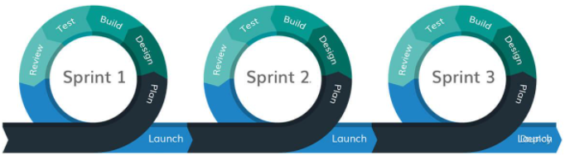

# Terms and Conditions

* Invoice shall be raised on each milestone, to be defined at the time of creation of Project Plan.
* In case the need to make the resource(s) available onsite for study/delivery or any other purpose the cost shall be borne by Client (a separate scope of work is provided by WebMobril as the need arises).
* This proposal will be only valid once we receive a signed copy of the same from Client’s end along.
* Deliverables listed in the proposal above will be referred to during the development of the project. Any new features, additional modules, major changes in work flow or any other element which is out of scope as per the above will attract a fresh ETA and quote which will be submitted separately by WebMobril.
* All content, images, texts, videos, Third party integration, services, API, Plug-in etc. information will be provided by Client. If any of those attracts any cost to be acquired, same will be borne by Client.
* WebMobril is not liable to write or publish the content on the project.
* WebMobril is not responsible for the delay of the project if the necessary information required by Client like API’s information, third party plug-ins, Payment gateways and shipping gateways info etc. is not provided timely by Client.
* WebMobril will provide 1 design concepts for Design work and there will be 2-3 revisions can be done as per Client remarks if more revisions required then these will be billable.
* WebMobril is not responsible for the delay caused by the malfunctioning of any third party software integrated with some other system appreciated works:
* General features not described in detail will carry out as per industry standards and will be supported by open source scripts when available.
* Domain Registration & Hosting Server for the installation of final product will be bought by the Client and provided to WebMobril.
* Neither party can hire/contact/work with either of its Customers/resources/former Customers directly or indirectly during the term of this contract and till 5 years without the written permission from the directors of the company.
* Lorenzo will ensure that the hosting server provided is compliant to the requirements for hosting server provided by WebMobril.